7-2 Discussion: Improving the Forests
Michael Surdek posted Feb 17, 2022 10:55 AM

I used the Ecdat HDMA data set for this activity, which contains 13 attributes of mortgage loan applications including credit score, marital status, race, and whether the mortgage was ultimately approved or denied. The decision tree was very easy to develop using the code from the textbook and the rpart function/package. This is built by taking passes through all of the variables and observations in the training data and creating decision nodes based on the values of the variable that provide the largest information gain. The decision tree is quite simple and accurately predicts about 91.1% of the training observations. This is a solid rate for a decision tree model, although not especially impressive given that 88% of the target variable values are "no".
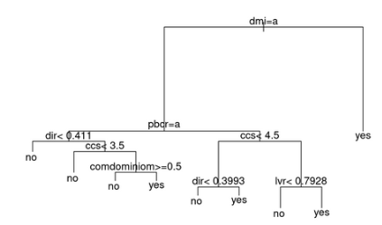

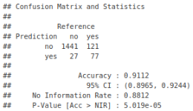

The random forest algorithm can be implemented in a very similar way as the decision tree, only using the randomForest function/package and setting some additional parameters such as the number of trees to build and the number of variables to randomly sample at each node. This particular algorithm randomly samples training data observations for each of the 500 trees, and also randomly samples 4 variables to consider at each node of each tree. The added randomness and the power of the wisdom of the crowd by utilizing hundreds of trees drastically improves the performance of the model. The accuracy of the random forest model on the training data is 99.94%, which is significantly better than the decision tree model. In fact, the random forest correctly predicted 1474/1474 no observations and 191/192 yes observations!

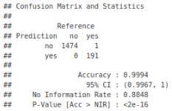

References
Williams, Graham. 2011. Data Mining with Rattle and R : The Art of Excavating Data for Knowledge Discovery. Springer New York. Retrieved from http://ebookcentral.proquest.com/lib/snhu- ebooks/detail.action?docID=770229

